BOLDFlash Mobile Division Training Plan and Guidelines

Smokie Lee

Southern New Hampshire University

BOLDFlash Mobile Division Training Plan and Guidelines

# Part I: Training

## Target Audience

The target audience for internal business processes, my area of focus, are the BOLDFlash Technical Mobile Division management team of department directors (Appendix A). These department heads are responsible for making important strategic decisions to align their departmental priorities with those of the company. This audience is interdepartmentally low-tech (Beer & Shelton, 2012); that is to say that they share the common jargon specific to all BOLDFlash employees, but their knowledge outside their department is limited. Providing additional details such as definitions and background information can greatly benefit such low-tech audiences (“TechWritingJCC - Chapter 4 Questions,” n.d.), while making sure your message is clear, concise, and relevant will benefit all audiences (Gerson & Gerson, 2013; Singh, 2012; “Write Clearly and Concisely,” n.d.).

## Message Needed

According to the case study, management agrees that communications - both internal and external - lack discipline and focus, and are in need of improvement (Beer & Shelton, 2012). These unique responsibilities require technical communications with management to be clear, concise, actionable, and relevant to their area of influence (Young & Post, 1993). In other words, they need an easy to understand message that will communicate to them quickly what they need to do, why they need to do it, when to do it, and how to do it. Internal business process memos should give managers the information they need to implement the process in their department (Gerson & Gerson, 2013) and how or where to discuss the effectiveness of the process after implementation (“Process Auditing,” n.d.).

## Message Critique

I have chosen to address the product enhancement memo from marketing as I feel it has the most potential for improvement. Regardless of audience, miscommunication in technical communication can lead to lossof credibility or even injury (Gerson & Gerson, 2013), so it's vital that your message be as concise and clear as possible. Conciseness, or the ability to keep a message brief but comprehensive(“Concise | Define Concise at Dictionary.com,” n.d.), makes a message more memorable (Singh, 2012) and improves its readability (Kurtus, n.d.). When writing for internal technical communications one should write to express not to impress; wordy messages take longer to understand, distract your audience, and can cause misinterpretation of your message (Moxley, n.d.; Singh, 2012). Usage of idioms like "rock the boat" and puns such as "generate some 'flash'" should be avoided. How is "flash" defined? What criteria will the marketing staff use to determine which enhancements will generate "flash"? Define ambiguous and subjective terms like "flash" and provide specific details to increase the relevancy of the requested information (“Write Clearly and Concisely,” n.d.).

The language of the message is too departmentally focused and does not provide enough detail or an action for the audience to take, which can lead to confusion and conflict (Gerson & Gerson, 2013). The ability to quickly, effectively, efficiently, and continuously innovate is key to a company's success (Schilling, 2012), and yet there is no mention how these new product enhancements will benefit the company. A sense of urgency is expressed, but no deadline or call to action is given, leaving the reader to wonder why they were included in the message and what - if any - action they should take. Adding a call to action and a specific timeframe helps reduce ambiguity (Ashe-Edmunds, n.d.) and gives readers a clear expectation of their role in the communication (Gerson & Gerson, 2013).

# Part II: Adaptation

## Guidelines for Successful Technical Communications

Analyze Audience. Identifying your audience is the single most important step in any communication (Barten, n.d.) because capturing and retaining your audience's attention will make your message more effective and will help them comprehend and act on the message much more quickly (“Write Clearly and Concisely,” n.d.). Confusing or irrelevant communications in technical writing can lead to miscommunications, a loss of credibility (Conger, 1998) or even to injury (Gerson & Gerson, 2013). Identifying and understanding your audience is key to providing clear, concise, relevant messages that successfully communicate with that audience (“Understand Your Audience,” n.d.) and is an important skill in any technical communicator's toolbox (Gerson & Gerson, 2013).

Identify Information. To best focus your message for your intended audience, it's important to determine what information the audience needs (Gerson & Gerson, 2013; “Understand Your Audience,” n.d.). For example, your boss may have told you to write a memo explaining how to print reports from the new time tracking software, but while researching your audience you discover that your some of your audience doesn't even know about the new software, while others know about it but don't know how to use it and therefore have no data to create a report from. Sending a message to these users about how accomplish a high-level task when they have been unable to begin a low-level task can cause confusion and loss of motivation (Gerson & Gerson, 2013).

Choose the Channel. Understanding your audience's needs can help your provide value to your technical communication (Marcotte, 2000) and determine which communication methods would be best suited (Root, III, n.d.). For example, you would not use traditional mail to notify upper management of a critical website outage that can potentially cause a loss of revenue. Likewise, announcement of a new hire would not likely be sent out to all employees on their company devices.

Write & Revise. An excellent way to ensure you’ve provided sufficient detail in your message is to answer the reporter's questions: who, what, when, where, and why (“Five Ws,” 2015). Who is the intended audience and who are the stakeholders? What do they need to know? When do they need to know it, or when do they need to act on this information? Why do they need this communication? Not every message can or should answer all of these questions, but asking yourself these questions provides an excellent framework during revision. Revision is a valuable method to ensure your message is delivered concisely and with the highest level of clarity and is one of the most important stages in the writing process (Gerson & Gerson, 2013). Revision might include removing unnecessary words, replacing large words with smaller ones, or realigning your definitions to match your audience's expertise level; all methods to help improve the clarity and conciseness of your message.

## New Communication Artifact and Explanation

Using the marketing memo as an example, let's apply the above guidelines to improve the effectiveness of this communication.

Analyze Audience. First, we need to identify the audience. The audience is currently listed as department heads, or management, which we established earlier is a low-tech audience that needs actionable information. Right away we can see that the subject line of our memo is too generic and doesn’t let the audience know what to expect from the message.

|  |
| --- |
| BEFORE |
| From: Kavita Patel - Director, Marketing  To: All department heads  Subject: Product enhancements  […] |

This subject line provides a clear understanding of what to expect from the attached communication.

|  |
| --- |
| AFTER |
| From: Kavita Patel - Director, Marketing  To: All department heads  Subject: New Process to Determine Product Enhancement Focus  […] |

Identify Information. Next we need to identify the message. The message management needs must include concise, actionable, relevant information they can act upon quickly. Providing background information, defining terms, and defining specific actions to be taken are all ways to communicate effectively with management. In the context of this memo, management needs to know who is included in the new process, what steps are taken in the process, and how terms are defined in context of the process. Action items should be clearly defined and enough information should be provided to complete the task. A simple way to include both detail and instruction is to provide a summary in list form.

|  |
| --- |
| BEFORE |
| From: Kavita Patel - Director, Marketing  To: All department heads  Subject: Product enhancements  […]  This new approach will give us a great story for our upcoming trade show in Las Vegas, so I know everyone will be behind us in this!  Kavita |

Simply adding bullet points provides a clear and concise summary of the information provided in the message, and gives structure to an otherwise unorganized block of text.

|  |
| --- |
| AFTER |
| From: Kavita Patel - Director, Marketing  To: All department heads  Subject: New Process to Determine Product Enhancement Focus  […]   * Marketing will provide a report detailing which enhancements are most requested by our users and being developed by our competitors. This should provide a framework for our next development cycle. * Marketing will collaborate with all other departments to identify which of these enhancements will be most cost-effective to develop in the next 3-6 months. This focus on the short-term should help generate excitement for our products in the marketplace.   This new approach will give us a great story for our upcoming trade show in Las Vegas, so I know everyone will be behind us in this!  Kavita |

Choose the Channel. Third, we need to determine the best method of communication for our message. A memo is a secure and common form of internal communication that is especially suited to process documentation (Gerson & Gerson, 2013). Email would not be an effective channel of communication as the amount of email the average employee receives makes it difficult to sort out the important from the mundane (Erwin, 2014). Adding the process document to an internal company wiki would also be an effective method; wikis are an excellent source of reference material for both current and future employees that is available 24/7 (Parker & Chao, 2007).

Write and Revise. Now that we know who the audience is, what the message should be and the best method to use to communicate it’s time to actually write and revise the message. Since this memo has already been written, we’ll focus on revision. The use of idioms and flashy language should be avoided, you should write to express not to impress. As stated previously, more details and context should be provided since the audience is low-tech. Presenting the information in a problem/solution setup would provide more background and information which will allow the intended audience to make effective decisions. The language is also too internally focused and doesn’t provide a compelling reason why this new process is good for the company.

|  |
| --- |
| BEFORE |
| From: Kavita Patel - Director, Marketing  To: All department heads  Subject: Product enhancements  Representatives from Marketing have been attending a number of industry trade shows this season. We are receiving a lot of feedback that customers are looking for more enhancements to existing products. We are also seeing our competitors paying more attention to enhancements.  I have directed my staff to focus on identifying enhancements that we can make, particularly to our new flash drive line. We're going to look at enhancements that can generate some "flash" in the marketplace for our product!  Time is of the essence with these new enhancements. We are confident we can keep these changes simple and not rock the boat too much. So that we can speed this along, the team will feed those requirements directly to Manufacturing.  This new approach will give us a great story for our upcoming trade show in Las Vegas, so I know everyone will be behind us in this!  Kavita |

Removing the puns and idioms provides more conciseness and lets the reader focus on the process outlined in the document. Providing details about the next steps in the process helps the reader understand their role in the process and the bullet points create visual organization to help clarify the message. Lastly, stating how to receive more information about the process helps increase credibility and provides a means for collaboration.

|  |
| --- |
| AFTER |
| From: Kavita Patel - Director, Marketing  To: All department heads  Subject: New Process to Determine Product Enhancement Focus  Marketing has received significant customer feedback regarding potential enhancements to our existing products, particularly our new flash drive line. We are also seeing an increase in new product enhancements put forth by our competitors which are generating market interest.  For these reasons, I have directed my staff to write a report identifying what enhancements have been requested, beginning with our new flash drive line. To reduce potential development or production disruptions, the department heads and myself will then meet to determine which of those enhancements most align with our business strategy in the short-term (3-6 months) and should therefore be the focus of our next development cycle.  This new process will help renew market interest in our product line and hopefully streamline the development process by providing a focus for our development cycles. For any questions, comments, or concerns, please communicate directly with me.  Summary   * Marketing will provide a report detailing which enhancements are most requested by our users and being developed by our competitors. This should provide a framework for our next development cycle. * Department heads will determine which of these enhancements will be most cost-effective to develop in the next 3-6 months. This focus on the short-term should help generate excitement for our products in the marketplace. * All questions should be directed to Kavita Patel (kpatel@BOLDFlash.net).   Kavita |

## Conclusion

The communication environment that exists within BOLDFlash is one of unproductive and unnecessary interdepartmental conflict resulting from lack of clearly defined business processes. Internal business processes and communications are filled with ambiguous language, significant knowledge gaps, and assumptions on all sides, and they lack definition with regards to roles and responsibilities. To be the most effective, any framework for communication must have clear processes, be standardized across the departments, and create a culture of collaboration (Burton, 2005). Such an environment should foster trust between departments while also challenging assumptions and generating new ideas. To this end, we have proposed a communication framework with established practices that will allow continued communication among the key stakeholders and provide a way for management to fulfill their responsibility to "encourage and foster a culture of collaboration" (Lash, 2012), because collaboration is one of the most crucial contributing factors to a company's growth (Gerson & Gerson, 2013). This framework consists of four steps: Analyze the Audience, Identify the Information, Choose the Channel, and Write & Revise. Following these steps should help employees at BOLDFlash create effective, successful technical communications.

References

Ashe-Edmunds, S. (n.d.). The Difference Between A Business Memo & A Business Letter. Retrieved October 13, 2015, from http://smallbusiness.chron.com/difference-between-business-memo-business-letter-57723.html

Barten, L. (n.d.). Business Corporate Communications Strategy. Retrieved October 20, 2015, from http://smallbusiness.chron.com/business-corporate-communications-strategy-2855.html

Beer, M., & Shelton, R. (2012). *BOLDFlash: Cross-Functional Challenges in the Mobile Division* (Brief Cases No. 4438) (p. 10). Harvard Business Publishing: Harvard Business School.

Burton, B. (2005, July 15). How to Define a Collaboration Strategy That Drives Business Value. Retrieved October 26, 2015, from https://www.gartner.com/doc/483308/define-collaboration-strategy-drives-business

Concise | Define Concise at Dictionary.com. (n.d.). Retrieved November 6, 2015, from http://dictionary.reference.com/browse/concise?s=t

Conger. (1998). The necessary art of persuasion. *Harvard Business Review*, *76*, 84.

Erwin, J. (2014, May 29). Email Overload Is Costing You Billions -- Here’s How To Crush It. Retrieved October 19, 2015, from http://www.forbes.com/sites/groupthink/2014/05/29/email-overload-is-costing-you-billions-heres-how-to-crush-it/

Five Ws. (2015, October 26). In *Wikipedia, the free encyclopedia*. Retrieved from https://en.wikipedia.org/w/index.php?title=Five_Ws&oldid=687657236

Gerson, S. J., & Gerson, S. M. (2013). *Technical Communication: Process and Product*. Pearson.

Kurtus, R. (n.d.). Conciseness is Key to Good Technical Documentation. Retrieved November 6, 2015, from http://www.school-for-champions.com/techwriting/concise_writing_important.htm

Marcotte, D. (2000). Determining the Needs of Your Audience. *Dateline Houston*, *40*(4).

Moxley, J. M. (n.d.). Write with Clarity. Retrieved November 5, 2015, from http://writingcommons.org/index.php/open-text/style/description/420-write-with-clarity

Parker, K., & Chao, J. (2007). Wiki as a teaching tool. *Interdisciplinary Journal of E-Learning and Learning Objects*, *3*(1), 57–72.

Process Auditing. (n.d.). Retrieved October 12, 2015, from http://transition-support.com/Process-Auditing_Technique.htm

Root, III, G. N. (n.d.). 5 Main Questions to Consider When Developing a Communication Strategy. Retrieved October 20, 2015, from http://smallbusiness.chron.com/5-main-questions-consider-developing-communication-strategy-15625.html

Schilling, M. A. (2012). *Strategic Management of Technological Innovation* (4th edition). New York, NY: McGraw-Hill Education.

Singh, G. (2012, April 13). The Art of Concise Writing. Retrieved from http://technicalwritingtoolbox.com/2012/04/13/the-art-of-concise-writing/

TechWritingJCC - Chapter 4 Questions. (n.d.). Retrieved October 9, 2015, from https://techwritingjcc.wikispaces.com/Chapter+4+Questions

Understand Your Audience. (n.d.). Retrieved October 8, 2015, from http://pcs.ieee.org/communication-resources-for-engineers/audience-purpose-and-context/understand-your-audience/

Write Clearly and Concisely. (n.d.). Retrieved November 2, 2015, from http://pcs.ieee.org/communication-resources-for-engineers/style/write-clearly-and-concisely/

Young, M., & Post, J. E. (1993). Managing to communicate, communicating to manage: How leading companies communicate with employees. *Organizational Dynamics*, *22*(1), 31–43. http://doi.org/10.1016/0090-2616(93)90080-K

Appendix A

BOLDFlash Mobile Division Organization Chart

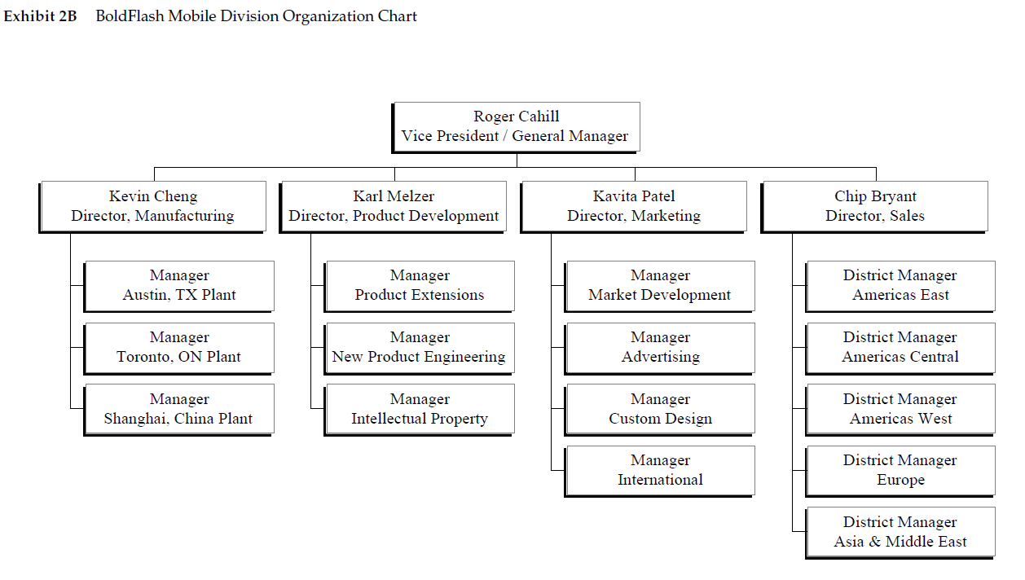

Appendix B

BOLDFlash Product Development Internal Memo Original Artifact

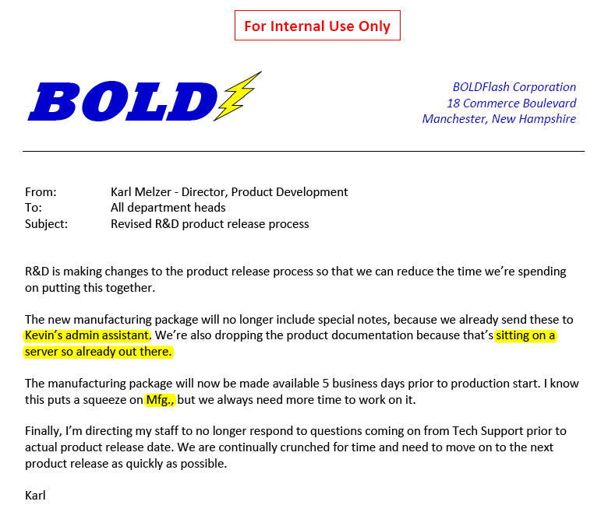

Appendix C

BOLDFlash Product Development Internal Memo Adapted Artifact

